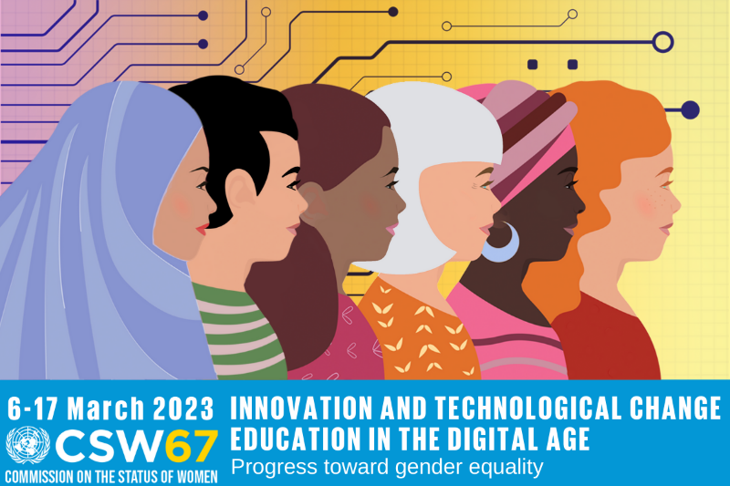
Overzicht van CSW67 events
Zie ook:
Laatste updates van WO=MEN’s compilatie:
https://www.wo-men.nl/agenda
Overzicht door UN Women van alle Formal Side Events:
https://www.unwomen.org/en/csw/csw67-2023/side-events/schedule
Toegang naar het NGO CSW67 Forum met Parallel Events:
https://ngocsw.org/ngocsw67/

Datum | Event | Tijd | Waar | Hoe | Door wie | Meer info/ registratie:
6-03-2023 | Digital Gender-Based Violence: How Technology has Affected LGBTIQ People’s Lives | 10:30 AM-12:00 PM EST | CCUN 2nd floor, New York | In-person | Outright International, ILGA World, CoC Netherlands, RFLS, Sweden, UNDP, and Colombia | https://ngocsw67forum.events.whova.com/Agenda/2866292
6-03-2023 | Achieving Gender Equality & Empowerment through Innovation, Technology and Education | 11:00 AM-1:00 PM EST  /17:00-19:00 CET | Online | Virtual | Soroptomist International | https://ngocsw67forum.events.whova.com/Agenda/2861763
6-03-2023 | Gender Equality in Tech | 17:00-21:00 CET | Equals Clubhouse, Raamgracht 6, A’dam | In-person – in NL | 75INQ & Equals | https://75inq.com/csw2023-side-event-amsterdam/
6-03-2023 | Formal side event  Towards a green and digital future: Opportunities for women and girls in public life and the workplace | 1:15-2:30 PM EST | UN headquartersConference Room 8 | In-person | Co-organised by the Kingdom of the Netherlands, the Parliamentary Assembly of the Council of Europe and Estonia | https://www.wo-men.nl/agenda-item/csw67-formal-in-person-side-event-towards-a-green-and-digital-future-opportunities-and-challenges-for-women-and-girls-in-public-life-and-the-workplace
6-03-2023 | Launch of Ukraine's Updated National Action Plan for Women, Peace & Security | 3:00-4:15 PM EST | Trusteeship Chamber, UN HeadquartersNew York | In-person | The Permanent Mission of Sweden to the United Nations and the Permanent Mission of Ukraine to the UN
7-03-2023 | Formal side event  Ending online GBV: how feminist approaches create inclusive online spaces for all women and girls | 8:30-10:00 AM EST  /14:30-16:00 CET | Permanent Mission of the Kingdom of the Netherlands to the United Nations, 666 3rd Avenue, 18th floor, New York | Hybrid | Netherlands Ministry of Foreign Affairs, the Count Me In! (CMI!) and the Our Voices Our Futures (OVOF) consortia | https://unwlobstorage.blob.core.windows.net/csw/54d379fd-108b-4a3f-9263-5fc34612349d_CSW67%20side%20event%20KNL%20+%20CMI!%20+%20OVOF.pdf  Registration in-person:  https://www.eventbrite.com/e/ending-online-gbv-how-feminist-approaches-create-inclusive-online-spaces-tickets-556180108677  Registration online:  https://us06web.zoom.us/webinar/register/WN_721csuRuSamnMeiry45fPA
7-03-2023 | NGO briefing by the Dutch delegation to the CSW67 | 3:30-4:30 PM EST | Permanent Mission of the Kingdom of the Nls, 666 Third Avenue, 19th floor, NY | In-person | Kingdom of the Netherlands | https://www.wo-men.nl/agenda-item/csw67-ngo-briefing-1
7-03-2023 | Gendered dynamics of online activism: women peace activists outline opportunities | 4:30-6:00 PM EST | Salvation Army Auditorium | In-person | PAX | https://ngocsw67forum.events.whova.com/Agenda/2866392
7-03-2023 | Virtual Event - Liftoff: Space Technology and Innovation for Gender Equality | 8:00 – 9.15 EST  /14.00 – 15.15 CET | Online | Virtual | United Nations Office for Outer Space Affairs | https://space4women.unoosa.org/events/virtual-event-liftoff-space-technology-and-innovation-gender-equality
8-03-2023 | Feminist perspectives on the impact of militarization on rural women | 6:15-7:45 PM EST | CCUN 11th floor | In-person | SIHA & PAX | https://ngocsw67forum.events.whova.com/Agenda/2866360
8-03-2023 | Feminist Foreign Policy PubQuiz | 6.30 – 8.30 PM EST | Blue Gallery, 222 East 46th Street New York, NY | In-person | Hivos, WO=MEN, Oxfam, We Lead, CMI!, Free to be Me | Op uitnodiging
9-03-2023 | Feminist Accessibility Protocol – Committing to disability-accessible and inclusive technology and innovation for gender equality and human rights | 11:00 AM-12:30 PM EST | Ford Foundation Center for Social Justice, 320 E 43rd St, New York | In-person | Women Enabled International (WEI), the Inclusive Generation Equality Collective, Ministry of Foreign Affairs of Finland, Disability Rights Funds & CREA | https://docs.google.com/forms/d/e/1FAIpQLSen7WIwVbb305D_XrRQXbFLFj73p6HSjut1e4jsF_cvto_6KQ/viewform?vc=0&c=0&w=1&flr=0
9-03-2023 | “Power Up” - Women’s Tech and Innovation Reception | 4:00-8:00 PM EST | Meta offices, New York | In-Person | Lila.help, StopNCII.org & Meta | https://powerupreception.splashthat.com/
10-03-2023 | Claiming online space to secure freedom, take action, create change | 9:00- 11:00 AM EST  /15:00-17:00 CET | Online | Virtual | Our Voices Our Future (OVOF) | https://ngocsw67forum.events.whova.com/Agenda/2862836
11-03-2023 | Digital Innovation: Tracking the Girls (TTG) Model in Ending Female Genital Mutilation/Cutting | 10:30 AM/12:00 PM EST | CCUN 10th Floor, New York | In-person | Amref Health Africa & Power to You(th) | https://ngocsw67forum.events.whova.com/Agenda/2866489
14-03-2023 | Reality check! Accelerating gender justice and SRHR in MENA through digital technologies | 6:15-7:45 PM EST | CCUN 8th floor | In-person | Oxfam Novib & Masarouna program | https://ngocsw67forum.events.whova.com/Agenda/2866369  https://www.masarouna.org/csw67
15-03-2023 | Technology & Innovation: Threat or Opportunity for Women's Safety? | 10:30-12:00 AM EST  /15:30-17:00 CET | CCUN 11th floor | Hybrid | Global Network of Women’s Shelters (GNWS) | https://ngocsw67forum.events.whova.com/Agenda/2866449  Registration  https://gnws.org/news/ngo-csw67/
15-03-2023 | Gender just water solutions and innovation | 10:30-12:00 AM EST | CCUN 8th floor | In-person | Women Engage for a Common Future (WECF) | https://ngocsw67forum.events.whova.com/Agenda/2866379
17-03-2023 | Bridging the gender digital divide: Using digital tools to advance the SRHR of women and girls, with case studies from Uganda and Malawi | 8:30-10:30 AM | Salvation Army Auditorium, New York | In-person | Sonke Gender Justice and its Power to Youth Consortium, Global MenEngage Alliance, MenEngage Africa, Amref Health Africa | https://ngocsw67forum.events.whova.com/Agenda/2874999
17-03-2023 | Feminists say “Enough!”  Countering anti-gender forces and fostering collective resilience | 6:15-7:45 PM EST | CCUN 8th floor | In-person | Our Voices Our Future (OVOF) | https://ngocsw67forum.events.whova.com/Agenda/2866442  Note: this session has a different name & format than originally in the NGO Forum
Versie 28 februari 2023

