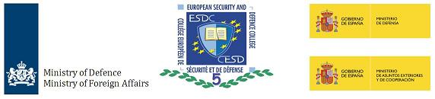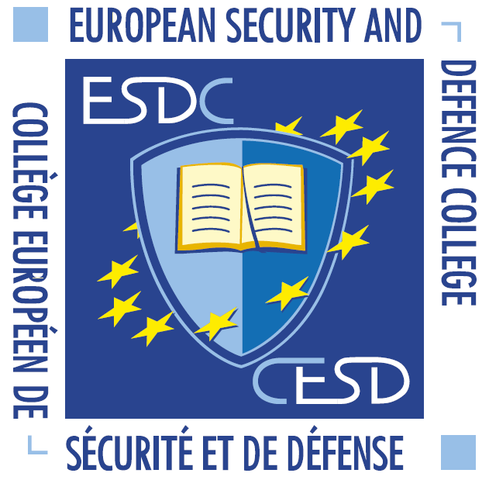

**Invitation to apply for the   
European Security and Defence College Course**

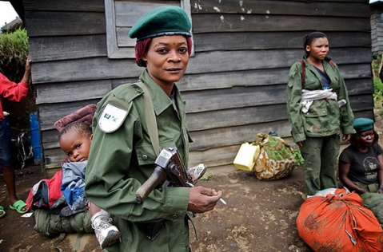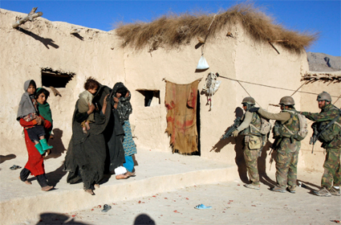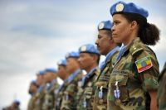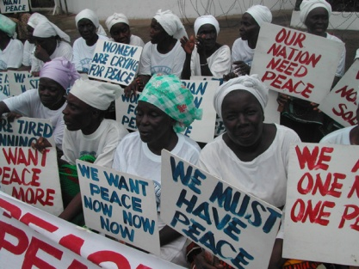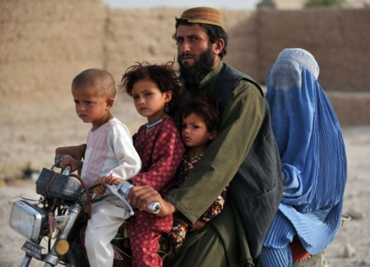

***A Comprehensive Approach to Gender in Operations***

***An international course for middle management***

***civilian and military professionals***

**24 November – 29 November 2024**

MoD Training Center (Majoor Jan Linzel Complex)

The Hague, The Netherlands

**Background**

Due to complexity of current operations, there is an increasing awareness of the need for both military and civilian personnel to be equipped with practical means to interact with local women and men. Men and women experience conflict and security differently. Consequently, their perspectives on conflict resolution and peacebuilding also vary. We need to listen and respond to both perspectives. Not just because it is the right thing to do, but because it makes our operations more effective and sustainable. Actively engaging women and men on equal grounds, within our own missions and institutions as well as in rebuilding post-conflict societies, is a matter of operational effectiveness. This implies changes in the way we plan and implement our operations, which is precisely what A *Comprehensive Approach to Gender in Operations* aims to accomplish.

This is a certified course under the auspices of the European Security and Defence College (ESDC).

This innovative international course, a result of the collaboration between the Spanish and Dutch Ministries of Foreign Affairs and Defence, responds to these demands by providing participants with the skills and know-how needed to face these new challenges.

The **5 day** course is based on the comprehensive approach to integrated missions and crisis management and builds on links between defence, diplomacy and development regarding gender and human rights issues.

**Aim**

The course aims to increase operational effectiveness by equipping students with the required skills and know-how to effectively implement the gender perspective in CSDP- and other international missions and operations.

**Learning Objectives**

At the end of the course the participant **should be able** to**:**

* Explain basic gender concepts and how attitudes and behavior towards gender may impact one’s own understanding, analysis and strategic leadership in operations;
* Understand the main principles and aims of the broader EU integrated approach to external conflicts and crisis of the EU global strategy;
* Describe how the gender perspective and the comprehensive / integrated approach complement each other;
* Explain the purpose of the Women, Peace & Security (WPS) agenda;
* Understand the technical and political aspects of gender in security sector reform (SSR) and demobilisation, disarmament and reintegration (DDR);
* Have a better understanding of the challenges and dilemmas facing military and civilian decision-makers regarding the protection of civilians and conflict-related sexual violence, and what is required to address these matters. It also aims to understand what sexual exploitation and abuse is and the zero-tolerance policy in the different international organisations;
* Recognize how conflicts impact men and women; the opportunities and challenges for women to participate equally in conflict resolution, crisis management and reconstruction and how to apply this to operational planning and implementation.

By the end of the course the participant **should be ready** to:

* Explain the significance of UN Security Council Resolution 1325 and related UNSC Resolutions to the operational mandates of EU/CSDP, NATO, UN, OSCE, AU and other missions;
* Identify entry-points and arguments to incorporate the gender perspective into operational planning including SSR or DDR processes;
* Promote the need to highlight the diverse security needs and perspectives of the local male and female population in a mission area as an essential element for increasing operational effectiveness and improving the overall security situation;
* Act effectively in a mixed working environment consisting of military, police and civilian personnel.

**Target Audience**

The course is primarily aimed at **middle management** military officials, civilians, including police and diplomats from EU Member States and EU institutions and relevant agencies, who are assigned to or interested in participating in (future) CSDP, NATO, UN, OSCE, AU or other missions/operations, or who are to be assigned to a position in a fragile state. Students from interested non-EU countries or multilateral organisations may also participate in the course.

No security clearance is required, as all materials used in the lectures will be unclassified.

**Training & Language**

* The language regime of the CSDP will apply. The working language is English and no interpretation will be provided. Participants should meet the Common European Framework of Reference for Languages (CEFR) Level B2 or NATO STANAG 6001 3-3-3-3;
* All lectures will be given indoors, both plenary lectures as well as working group sessions;
* Before the training course, students will complete an online preparatory module via the ESDC International Distance Learning (IDL) system;
* Participants will complete an evaluation survey online form to assess the quality of the course;
* Participants will receive an ESDC certificate upon completion of the course.

**Duration**

**The course runs for five days (Monday 25 Nov 0800 hrs to Friday 29 NOV 1500 hrs) .**

**The registration and ice breaker start on Sunday evening 24 Nov 1800 hrs.**

**Methodology**

Topics are examined through Internet Distance Learning (IDL), lectures, plenary discussions, exercise and working groups. Each participant is encouraged to take an active role and share their experiences and expertise during the course.

Reading material for individual study and a mandatory online module - *An introduction to gender-sensitive peacekeeping operations* - will be provided in advance of the training course in order to ensure a common basic level of knowledge among the participants.

Working group discussions will be used to deepen the understanding of certain areas.

**Course Content**

**(I) Introduction: Gender and the Women, Peace & Security agenda (WPS)**

Gender in operations and the WPS agenda

EU policy and definitions on gender and WPS in the CSDP

1. **Concepts and context**

Key gender concepts

Integrated approach in international missions

Gender analysis

Sexual exploitation and abuse policies

1. **Gender in SSR and DDR processes**

Introduction to gender in security sector reform (SSR) and demobilisation, disarmament and reintegration (DDR)

Mainstreaming gender in SSR and DDR

1. **Gender in local mediation**

Gender-inclusive mediation and advocacy

Incorporating gender in local mediation

1. **Conflict-related sexual violence**

Conflict-Related Sexual Violence (CRSV) and Protection of Civilians (PoC)

CRSV in relation to the wider continuum of Gender-Based Violence (GBV)

1. **Implementing a comprehensive approach to gender in operations**

The gender expert’s perspective

Integrating gender into the planning process

**Application & Selection**

**Application forms must be sent by 18 Oct 2024**. Those wishing to attend the training course should seek approval through their authorising mechanisms in their respective ministries or organisations. The application form must be signed by the participant and their authorising officer.

**NOTICE:** *The course is free of charge*.

Applicants must have one of the following job profiles:

**MILITARY**: Rank of Captain up to Colonel.

**CIVILIAN**: Officials from ministries of foreign affairs, defence, interior affairs, EU institutions or agencies and multilateral organisations who will be assigned to: operations in fragile states or relevant embassies/permanent missions/departments or participate in short missions / expert pools.

**NOTICE:** *Applications received after the deadline will only be considered if space is available*.

**Accommodation, Meals & Travel**

Single room basic accommodation is available at the training center

Majoor Jan Linzel Complex, Brasserskade 227A, The Hague, The Netherlands

Detailed logistical and administrative information will be provided upon confirmation of the admittance to the course.

Travel expenses to and from The Hague must be covered by the sending organisation. Participants should check if they require a visa to travel to The Netherlands. The sending organisation is responsible for arranging visas for the participant(s).

**Dress code**

**MILITARY AND POLICE**:

Icebreaker: Smart casual

Opening session and closing ceremony: Service dress uniform (jacket, tie and ribbons)

All other sessions: daily service uniform / working uniform

**CIVILIAN**:

Icebreaker: Smart casual

Opening session and closing ceremony: Business attire

All other sessions: Business casual

Official dinner - dress code for all: Smart casual

**Contact & Application**

Completed application forms should be sent to

course director CDR Ella van den Heuvel

Email: [PN.vd.Heuvel@mindef.nl](mailto:PN.vd.Heuvel@mindef.nl)

**Please send your application form latest 18 Oct 2024**

After sending your application, you will receive a confirmation by e-mail.

**We will let you know if we can offer you a place in our course latest 31 Oct.**

**APPLICATION FORM**

**ESDC ESP-NLD Course ‘A comprehensive approach to gender in operations’**

**PERSONAL DATA**

FIRST NAME

SURNAME

|  |  |  |  |  |  |  |  |
| --- | --- | --- | --- | --- | --- | --- | --- |
| |  | | --- | | **COUNTRY** | |  | | |  |  | | --- | --- | | **GENDER** |  | | MALE | FEMALE | |

# PASSPORT / IDENTITY CARD NUMBER

PHONE NUMBER (mobile)

ORGANIZATION (and SERVICE)

E‐MAIL

**PROFESSIONAL DATA**

|  |  |  |  |  |  |  |  |  |  |  |  |  |  |  |  |  |  |
| --- | --- | --- | --- | --- | --- | --- | --- | --- | --- | --- | --- | --- | --- | --- | --- | --- | --- |
| **SERVICE**   |  | | --- | | ARMY | | NAVY | | AIR FORCE | | Military POLICE | | CIVILIAN | | POLICE | | **RANK / POSITION**   |  |  | | --- | --- | | OR 5 – OR 7 NCO | OR 8 – OR 9 SENIOR NCO | | OF 1 LIEUTENANT/ JG LIEUTENANT | OF 2 CAPTAIN/ LIEUTENANT | | OF 3 MAJOR /LT. COMMANDER | OF 4 LIEUTENANT COLONEL/COMMANDER | | OF 5 COLONEL/CAPTAIN | OF6 - OF 9 GENERAL / ADMIRAL | | OTHER | | |

PREVIOUS INTERNATIONAL SERVICE

BRIEF DESCRIPTION OF CURRENT ASSIGNMENT

EXPECTED INTERNATIONAL SERVICE

PERSONAL AIM WITH THE COURSE

SIGNATURE APPLICANT:

**Send this form to the Course Director CDR Ella van den Heuvel:**

[**PN.vd.Heuvel@mindef.nl**](mailto:PN.vd.Heuvel@mindef.nl)

***Subject: Gender course 2024 application***