Session: Shrinking space of Woman Human Rights Defenders

April 19th 2018

13:30 0 17:00 hrs

New Babylon Meeting Center

The Hague

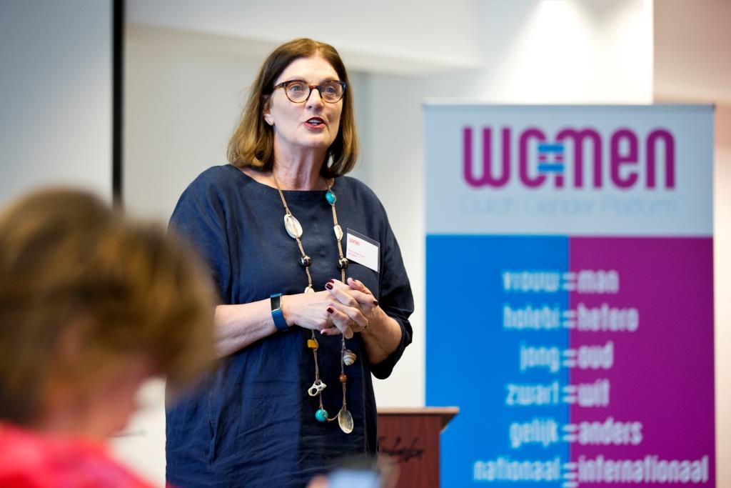

Welcome and introduction by Edith van der Spruit, director WO=MEN

During this afternoon session of the WO=MEN member meeting, three Women Human Rights Defenders tell their experiences and the ‘shrinking space’ they encounter more and more:
Visaka Dharmadasa, chair of the Association of War Affected Women in Sri Lanka,
Ana-Maria Rodriguez, human rights lawyer in Colombia, and
Thalia Malmberg, program officer Human Security Collective.
After a short introduction they join the conversation with Jelmer Kamstra, researcher and senior policy officer at the Dutch Ministry of Foreign Affairs and Sascha Gabizon, executive director of Women in Europe with a Common Future.
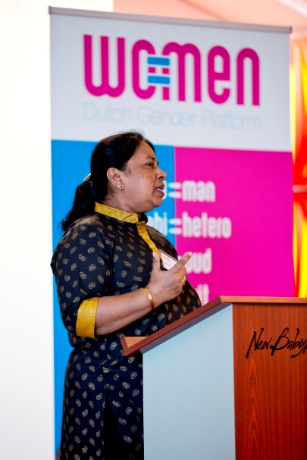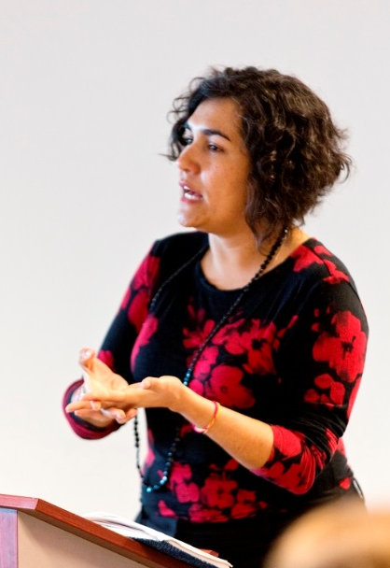
Visaka Dharmadasa Ana-Maria Rodriguez Thalia Malmberg

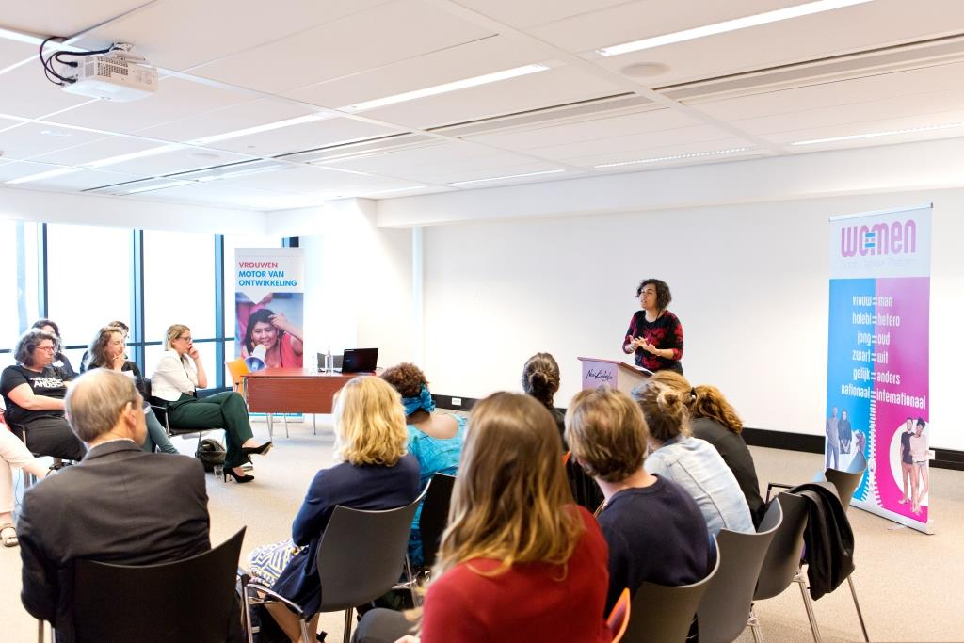

WHRD’s are labelled as terrorists, they get limited financing and have small organizations. Further, NGO’s are being self-censored in their work; afraid of sanctions, they limit themselves in their work place and the subject they work on. There are problems in accessing bank accounts and donor money is not transferred in time. “Due diligence” requirements are too high, so organizations are discouraged and stop with their work. Many NGO’s feel alone in this, thinking this only happens to them.

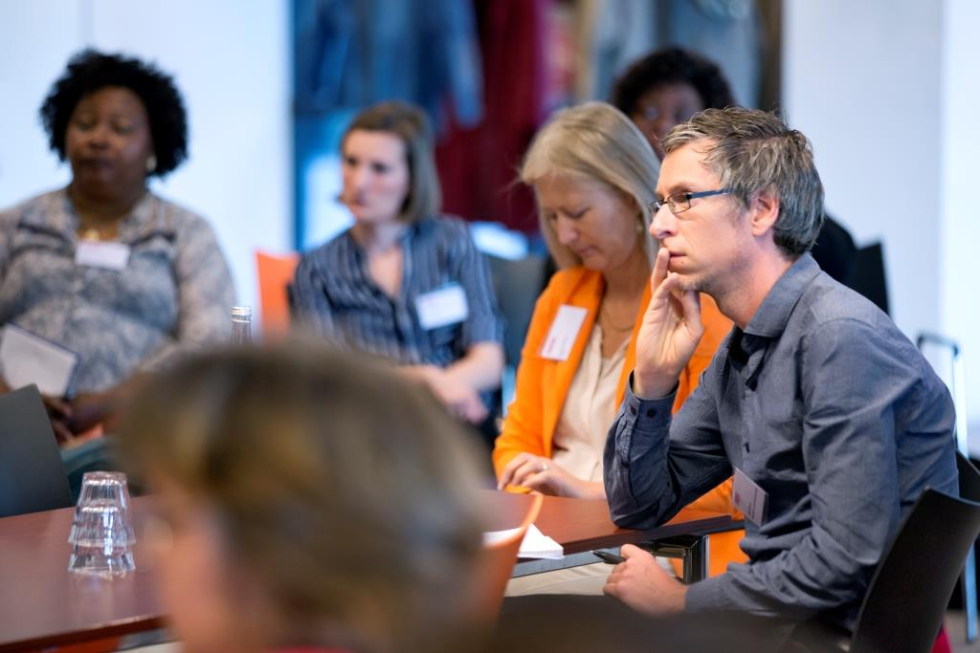
According to Jelmer Kamstra we need to ‘play with the system’. It is not us against them, but we have to work together to benefit. One of the preconditions are networks and working collectively.
Sascha Gabizon argues we need to support the women’s movement as networks and provide juridical support. It is difficult to ask governments for support. There is a lot happening right now: the MeToo movement, femicide, big demonstrations in the streets (women’s marches), and this has opened people’s eyes. It is a real opportunity now to pose some concrete proposals about how women’s organizations can get access to money. Funding can reach WHRD, but we can do better.
Sascha also argues it is different to work with WHRD’s, in ways of protection and taking them out of the country, because they often have children/families to come along.
Ana Maria Rodriquez also argues we need to work collectively and we need special protection programs for WHRD’s, better and easier access (to money) and we need to advocate. People need to work more broadly and raising particular issues, helping pushing different aspects of the situation. A new trend has started with women’s organizations and LGBTI organizations working together.
Jelmer Kamstra says he is struck by the fact that the shrinking space is getting so close to home, like the killings of journalists in Malta. Even the Netherlands have gone backwards. The human rights discussion is becoming much broader; it is a widespread phenomenon, with all types of activists being targeted. The social aspect of the government working on capacity strengthening is not always enough. You need to target/tackle the environment. Capacity strengthening of local women in a project in India had high impact, but also had negative outcomes due to negative reactions of family and friends. It would be good to focus on consequences for the family.
In Colombia the level of violence is high. The collectiveness struck Jelmer. Local collectiveness is important in the country, but also international connection is.

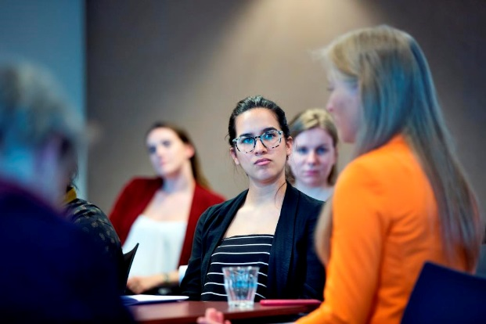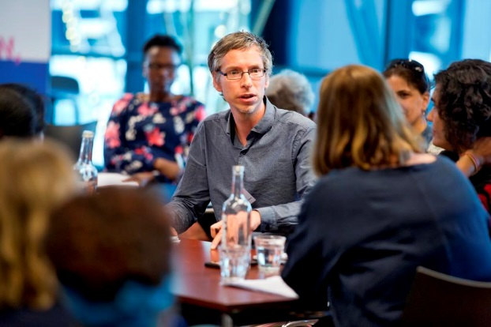

Regarding to the financial aspect, there must be risk and trust. Financial organizations take all the risks and money but not when it comes to NGO’s; banks will refuse and are afraid that money will get lost. They have a narrow view and want organizations to be similar to them.
Trust is important in financing small organizations. Organizations get little time to show results (three months), so they try to make a program but end up missing the idea of social transformation. According to Thalia Malmberg, fast results work counterproductive and damaging because people try to fix things in a very short time. It lacks to see where the change happens.

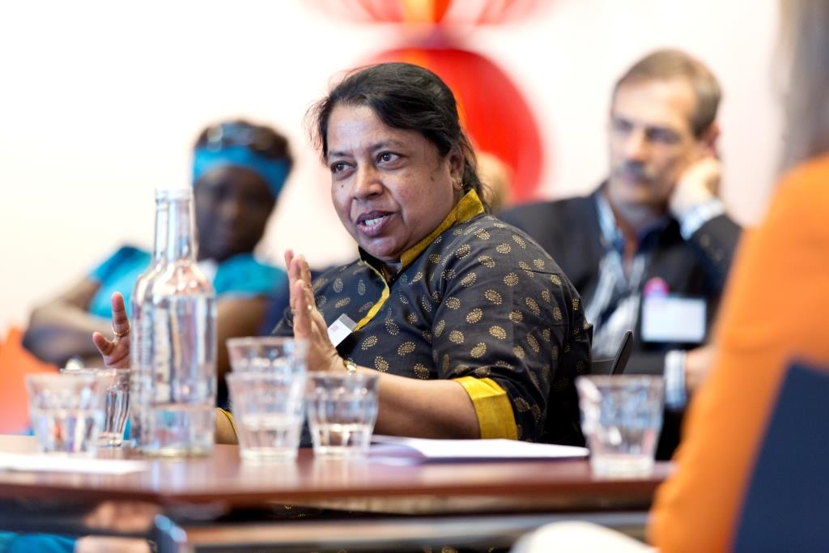

Visaka Dharmadasa argues that financial accountability is very important but when someone has to do everything and all of their time is spent at fund raising, they cannot do the actual work. We need some mechanism that the donor trusts us. However, capacity is limited. Big organizations give less time because they also need to do reporting. We have to be accountable and do the good work. There is no assurance that when we start a project, we can finish it. If we want transformation, it needs continuous funds.

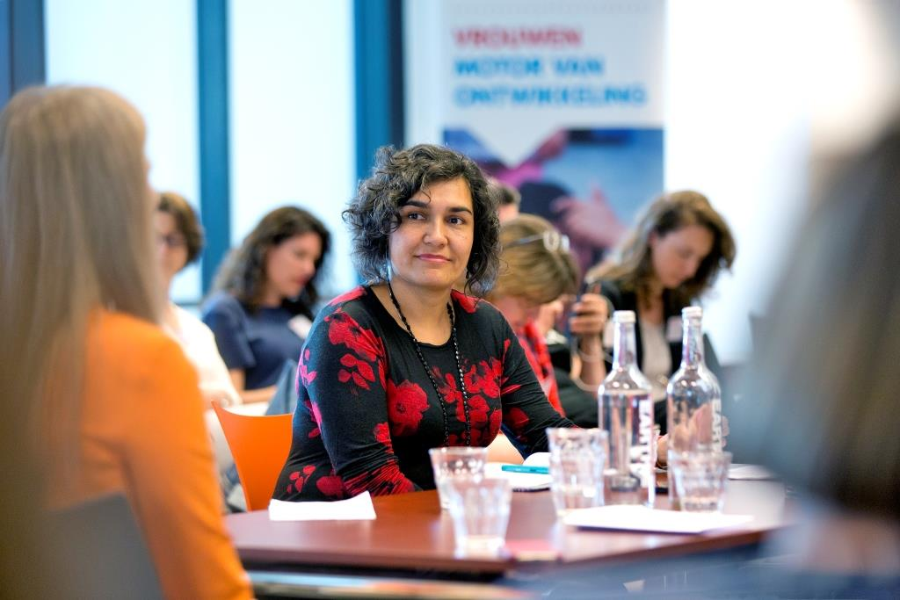

According to Ana Maria Rodriquez, it is difficult to do all of the process in short-term projects. We create expectations with the victims and the community but there is no way to guarantee the promises we made in such short time. The idea of transformation, if we want transformation, needs to be in a longer period of time. Or there need to be other ways to achieve them in stages.
Edith van der Spruit asks if it is a discussion to be completely independent or to work also with Northern organizations.
Visaka Dharmadasa does see some North-South relations that work. It is better to be independent, to receive from local sources. We would like to partner for development but sometimes we better work alone, because there can be some sensitive information you cannot report. Local money is needed for local sensitive issues and initiatives. When we get money from Norway for example, we can do more, but most work has done voluntarily.
According to Ana Maria Rodriques, it depends, being independent or work together. It is not an issue whether the relation is North-South, it is more conventional. It is nice to have an international partner, that is also a strategic choice; together you can do more. Sometimes it is not good and you spend more time creating some papers, while you miss working on what you should. It also creates unhealthy power dynamics according to Thalia Malmberg. Big organizations are gatekeepers for funds and keep the money.

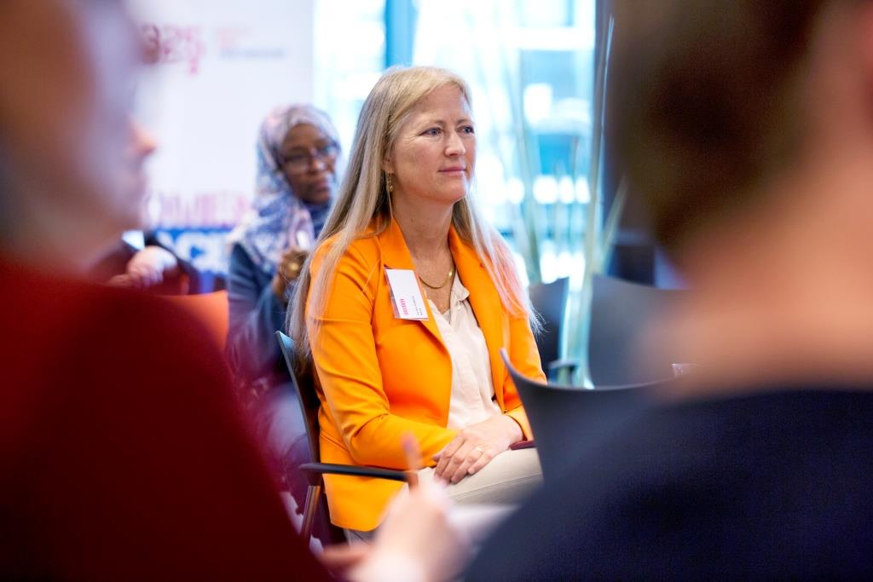
Sascha Gabizon argues that we want more accountability. Lots of money goes to proving accountability instead of proving your impact. We should not force local organizations to work with a business for example. Funding should be made priority for local organizations. This will be easier without detailed reporting. Further, an emergency pot would be useful, when an organization is threatened to close. The North-South partnership should be equal.
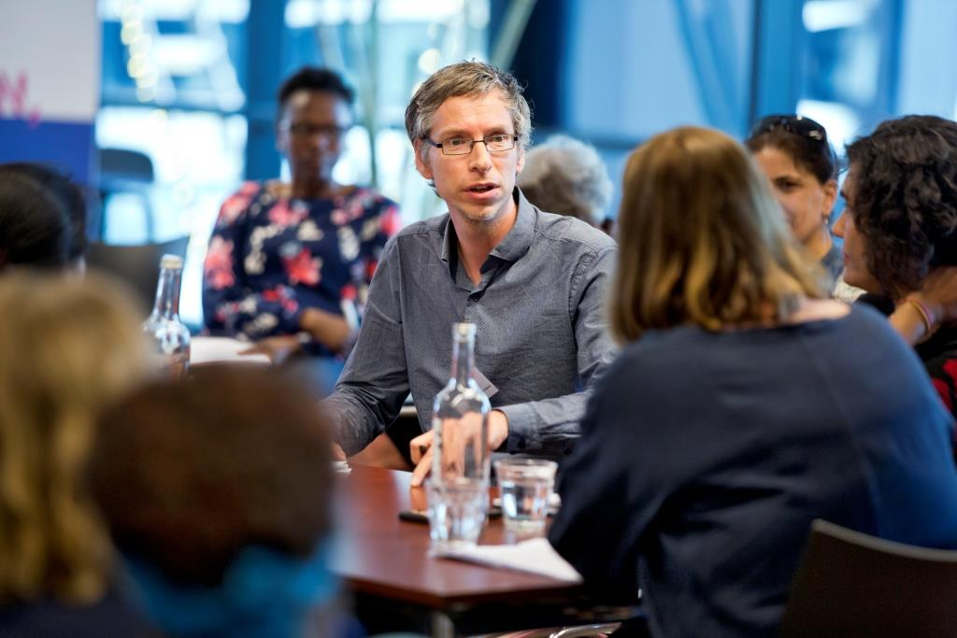
Jelmer Kamstra argues that you are dependent from money and you have accountability towards the donor. This is difficult to escape from. Organizations need to become a copy of the donor, to get most money. When you are working bilaterally, with governments, you cannot finance too critical voices. This changes the mission and stops organizations being confrontational to play the system. The donor pushes organizations to become professional, so they hire professionals in their organizations. However, when you have educated professional staff you need more money. So it affects your strategy.
Accountability procedures are based on trust. You need to report this to the parliament (not the ministry), because this problem consists in many sectors.
Margriet van der Zouw argues that every year when they are in New York for the Commission on the Status of Women (CSW), they see an increase of religious forces with a lot of money. She asks if the WHRD’ers also experience these religious forces in their work. Something that creates a bigger polarisation, the opposition in civil society getting bigger. For example regarding the Vatican and Russia; those organizations are getting stronger.
Visaka Dharmadasa thinks these religious forces are indeed increasing. In any society religious organisations have a big say. Monks tell us how to live, however that is not Buddhism. Those things have to be tackled within your society. Big NGO’s tell people they cannot exist (LGBTI). It is becoming more violent. Vatican linking with Russia is getting stronger and more detailed.
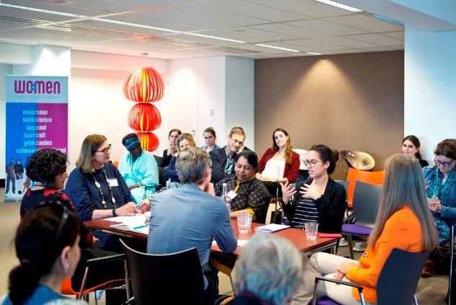
Someone from the public argues that in the Netherlands, we recognize that religious groups are getting more power. People wanting to get elected without content and people follow them blindly. As a refugee from Kurdistan, this person does not feel secure in the Netherlands, in what she can say and to whom; on an individual level on the streets for example. To solve this, we need to be solidair, work collectively, try to understand each other and learn from each other. Dutch values are not the only values. Refugee people also bring good values with them.
Ana Maria Rodriquez thinks fundamentalist groups are dangerous. Some religious sections do support women’s rights however. There are different sectors from different religions, but suddenly they all were friends on the agreement against voluntary abortion as if women would do abortion on any time, in any place, whenever they wanted. They fear the possibility of women to demand the right about what was happened to them in the conflict. So the level of violence against WHRD is increasing. Women are the biggest target in this.
Visaka Dharmadasa argues that the core of all religions is not at all different from each other. The core is good. Extremism is there in every form.
There is a question from the public if the WHRDs have suggestions about how to protect the shrinking space, women’s rights and WHRDs. There is argued for example that we need to prevent Civil Society Organizations to be enemies as they are competing for money. We need discipline, respect for each other and working together. We can do it ourselves.
Thalia Malmberg thinks we need solidarity, even when it’s not always financial profitable.
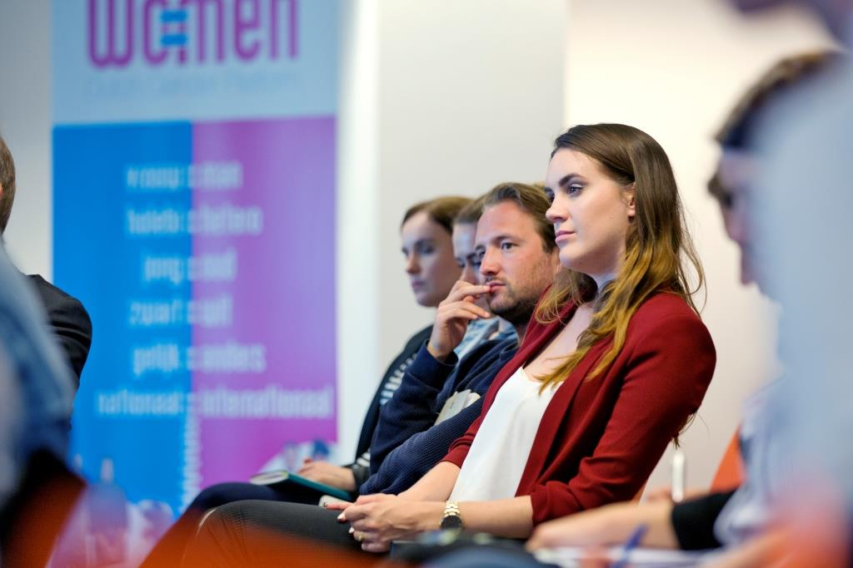

According to Sascha Gabizon we need to support these women’s organizations, give them funding, lobby activities, working together nationally and internationally. Further, we need to make sure if there is a media campaign against them, that we have an anti-campaign. We need to be careful how we communicate, not with hate, but that we respect human rights approaches. We need women’s constituency in peace-making and women in parliaments. The diversity of women’s organizations is important; we need to embrace this diversity and the different interpretations that exist.
Embracing diversity can be difficult and is important to think of this as a mind-set.
Further, we cannot say that religion is only bad. Religion can be liberating to many people and good things come out of it, for example things like ‘de Voedselbank’.
We need to open up, be transparent and trust another organization, giving your knowledge away. We need to share. Women groups are not homogenous. There are points that share a common ground, but there are also much intersections and class issues. We need to get everyone on board, also men. Rape is for example not only about women, but also about men who rape or get raped.
Thalia Malmberg: we need to support local groups, because they are the only ones who can do the work. We cannot tell them as a Dutch or international organization what to do and that we need to implement gender etc.

